Contents

1. How to install add-in 2

2. Add-in settings 7

3. Install instruction 9

4. How change text and images 10

## How to install add-in

1. Go to manifest_prod.xml file and check if it contains correct add-in url. (For test you can use https://ashy-ocean-024851f03.azurestaticapps.net )

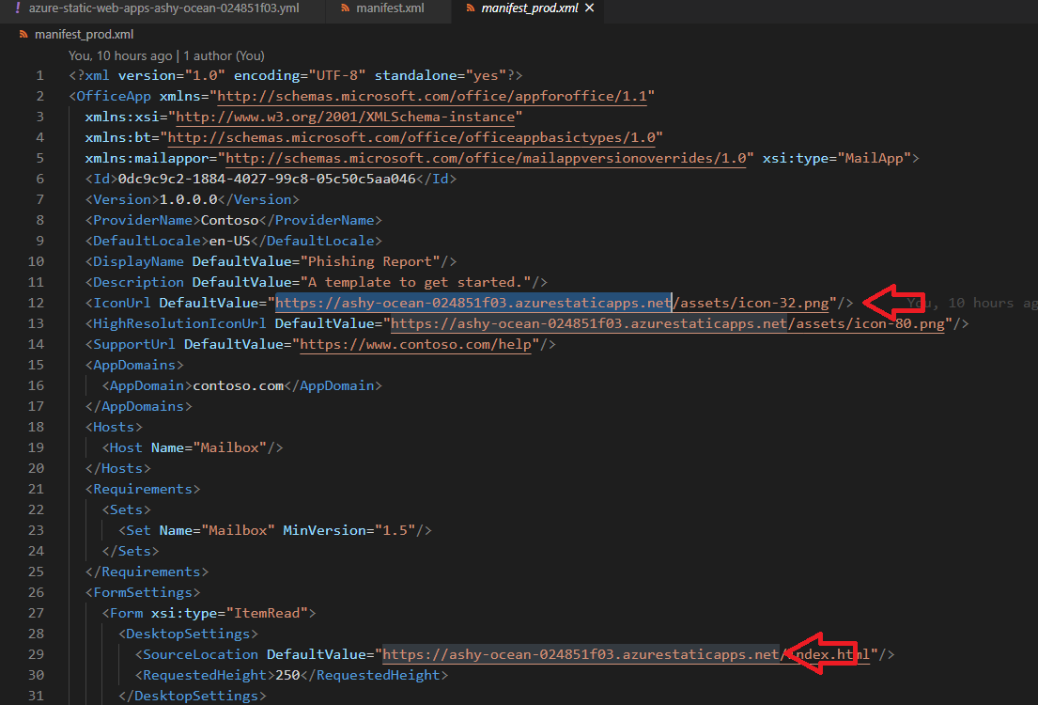

1. Go to Office 365 Outlook, open any email, open menu “Get Add-ins”

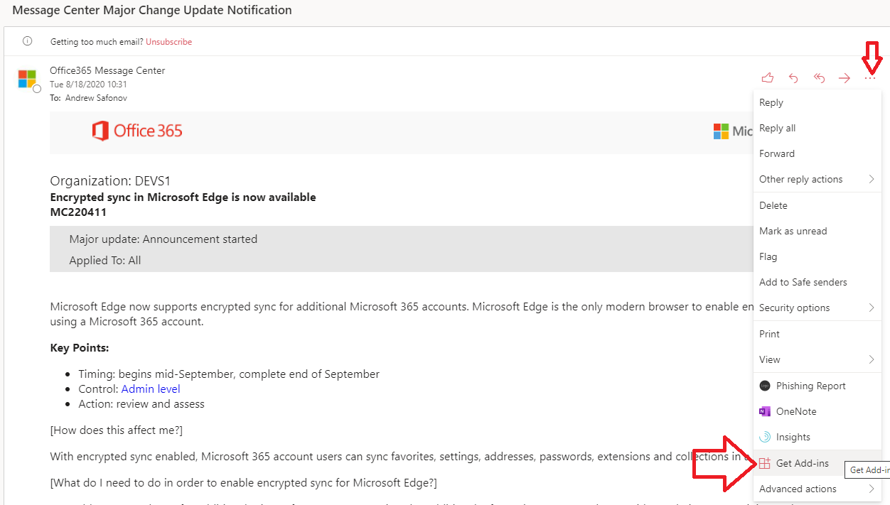

1. Add add-in from file

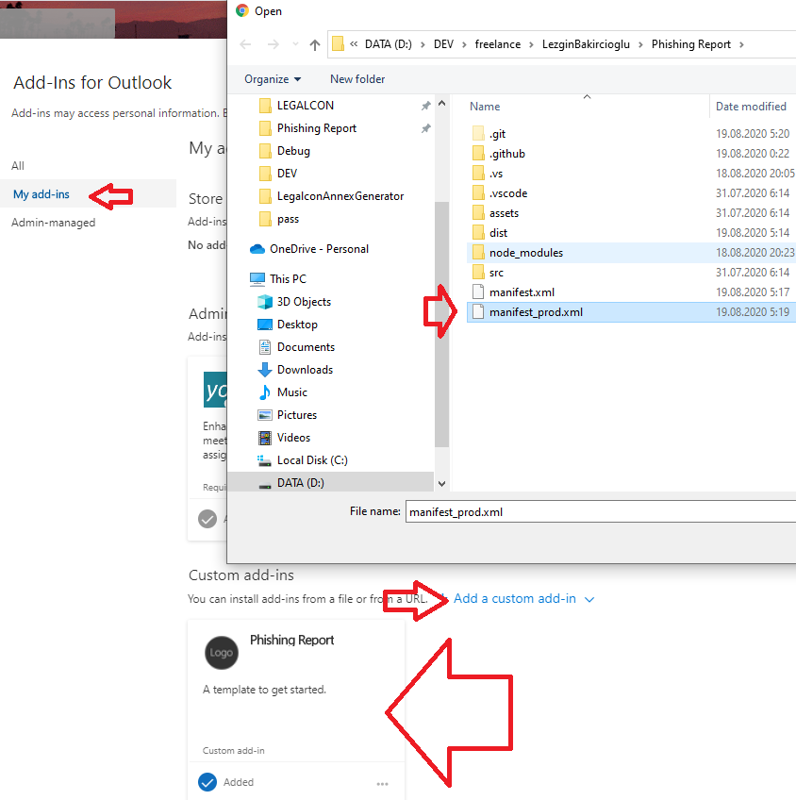

1. Go to email read. Then open menu and open “Phishing Report” add-in

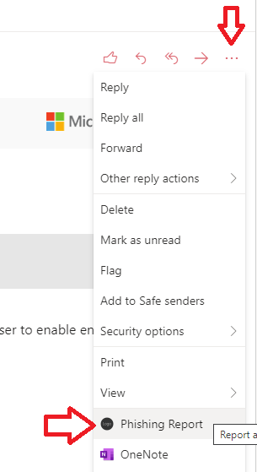

1. Then pin add-in. Pinned add-in will automatically open then you open email. No need open it every time.

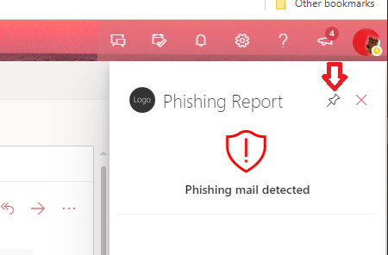

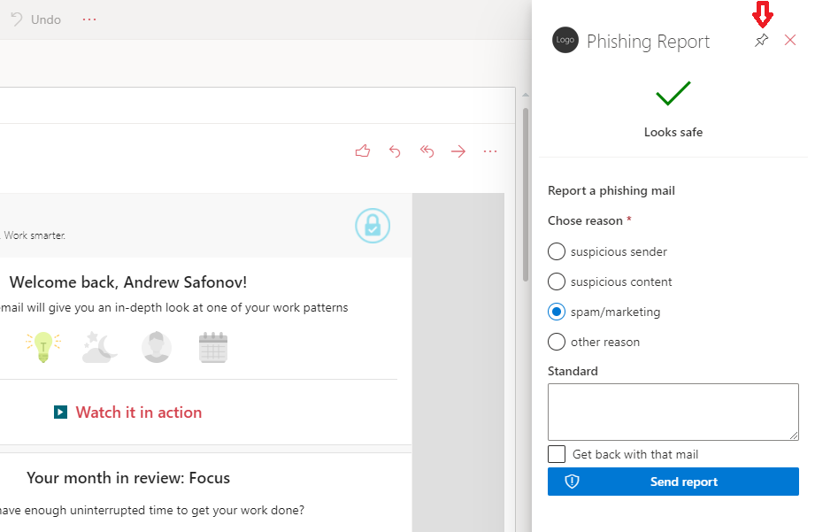

## Add-in settings

Add-ins settings stored in settings.json file

{

  "AutoDetect": false,

  "Headers": ["phishing title", "Password (reset|test)"],

  "Contents": ["phishing body"],

  "Emails": ["Jane@DevS1.onmicrosoft.com"],

  "ApiUrls": ["{url}/report?rid={rid}", "https://www.google.com/"]

}

AutoDetect – if true then add-in try detect phishing email by “Headers” or “Contents” and do api call to Gophish link if detected. If false then User need send report by button click (default behavior)

Headers – array off words or RegExp expressions to detect phishing mail in email subject. It uses JS RegExp.

You can test RegExp on <https://regex101.com/> site.

Example:

"Headers": ["phishing title", "Password (reset|test)"],

Contents – array off words or RegExp expressions to detect phishing mail in email body. It uses JS RegExp.

You can test RegExp on <https://regex101.com/> site.

Example:

"Contents": ["phishing body"],

Emails – array off emails that source email forward when user send report

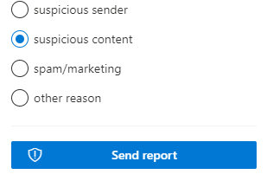

Example:

"Emails": ["Test@DevS1.onmicrosoft.com"],

ApiUrls – array off Api urls that call then phishing ,ail detected or user send report.

Possible use 2 variable from target mail {url} and {rid}

{url} - full Gophish url from mail “http://phish_server/?rid=1234567”

{rid} – rid value from Gophish url “1234567”

Example:

"ApiUrls": ["http://localhost/report?rid={rid}", "https://www.google.com/"]

Will call <http://localhost/report?rid=1234567>

And <https://www.google.com/>

## Install instruction

Addins use only html and JS files. To build addins open project in Visual Studio Code or open project in terminal. And Execute build script by run Build task in VS Code or by npm run build command in terminal.

Build requires Node 12.x version.

You can also get files from dist.zip from Releases on GitHub. Make sure if it contains latest add-in version

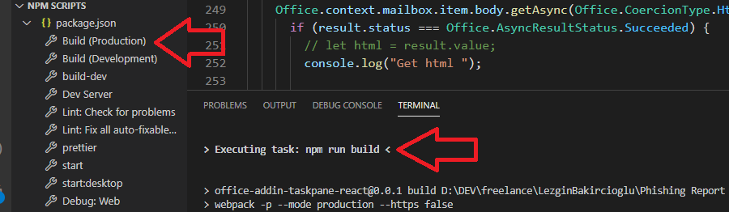

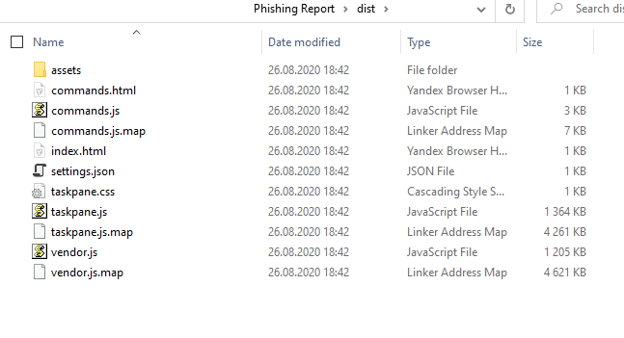

For test hosting uses Azure Static Web App (Preview). Also, possible use for hosting any hosting that support static files. Make sure that manifest file contains correct urls.

## How change text and images

Add-in status text and images set in function getHeader line 371 App.tsx file

  const getHeader = (): any => {

    let ret = (

      <Fabric>

        <FontIcon iconName="MailTentative" className={classNames.red} />

        <Label>Please send report if it is phishing email</Label>

      </Fabric>

    );

    if (appSettings?.AutoDetect) {

      if (mailState.isSafe) {

        ret = (

          <Fabric>

            <FontIcon iconName="CheckMark" className={classNames.green} />

            <Label>Looks safe</Label>

          </Fabric>

        );

      } else {

        ret = (

          <Fabric>

            <FontIcon iconName="ReportHacked" className={classNames.red} />

            <Label>Phishing mail detected</Label>

          </Fabric>

        );

      }

    }

    if (mailState.isReported && mailState.isGophish) {

      ret = (

        <Fabric>

          <FontIcon iconName="MailCheck" className={classNames.green} />

          <Label>Congratulations! You detect test phishing email.</Label>

        </Fabric>

      );

    }

    if (mailState.isReported && !mailState.isGophish) {

      ret = (

        <Fabric>

          <FontIcon iconName="MailAlert" className={classNames.green} />

          <Label>Phishing email report sent!</Label>

        </Fabric>

      );

    }

    return ret;

  };